**DATA VISUALIZATION ASSIGNMENT**

**Questions:**

***1. What is the distribution of passenger ages on the Titanic?***

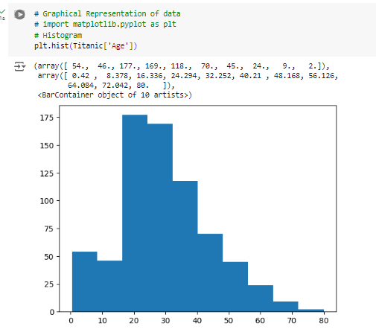

Ages between 20 to 40 have more travellers than other ages of travellers as per above graph

***2. How does the survival rate vary based on passenger class (Pclass)?***

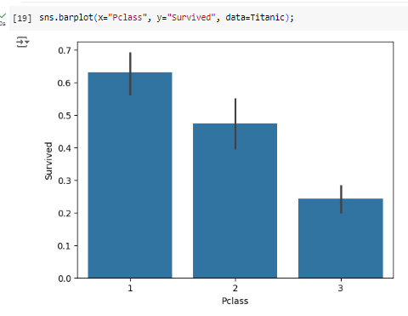

The Higher the class is the higher the survival rate

***3. Is there a relationship between the fare paid and the likelihood of survival?***

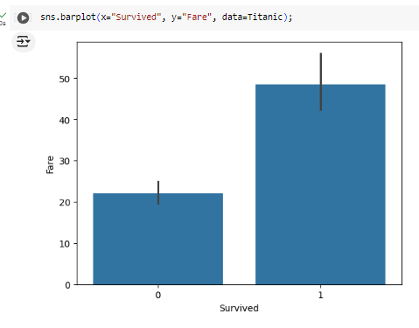

The Higher the fare paid is the higher the survival rate

***4. How does the survival rate differ between male and female passengers?***

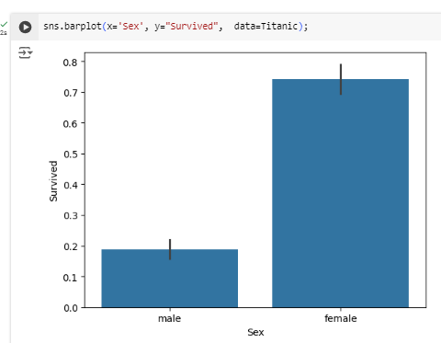

Female has higher the survival rate than the male

***5. What impact does the number of siblings/spouses (SibSp) or parents/children***

***(Parch) aboard have on survival?***

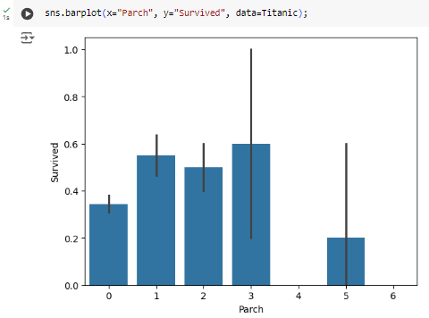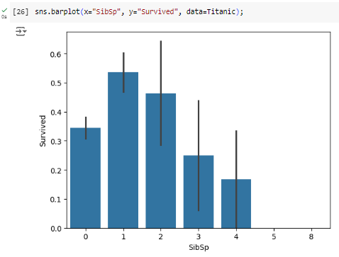

Siblings’ having 1 & 2 has higher the survival rate than the other numbers

Parch having 3 no’s have more probability of surviving than others.

***6. Are there any significant differences in survival rates among passengers embarked***

***from different ports?***

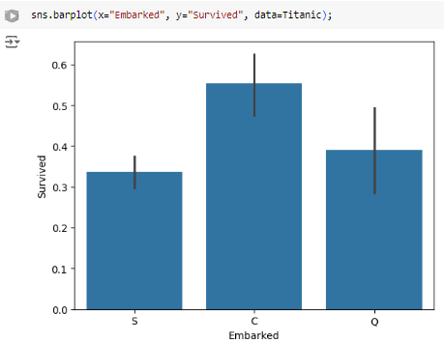

People who embarked from “C” port have higher probability of survival.